Aion 2 Level 1–45 Ultimate Speedrun Guide

Downtime Priority

Whenever you have downtime:
- Weapons (+5 max).
- Accessories (+5 max).
- Daevenation
- Skills Upgrade primary damage skills
- Stigmas
- Titles Equip BIS titles
- Achievements Claim completed achievements for stat/currency payouts
Visual Map Legend
Color / Symbol | Route Classification
Yellow Arrows | Main Story Quest (MSQ)
Green Arrows | Side Quests
Orange Arrows | Seal Dungeons
Black Arrows | Kisks

Phase 1: Levels 1–9
- Follow core MSQ

Phase 2: Levels 10–16

Part 1
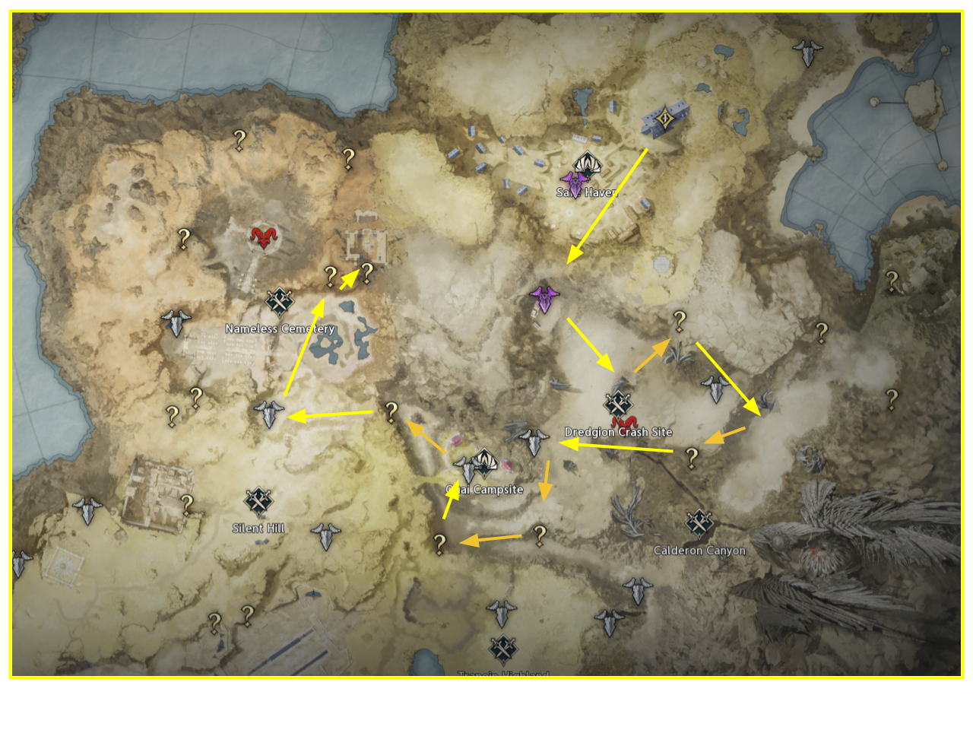
- MSQ Push
- Seal DG Detour

Part 2
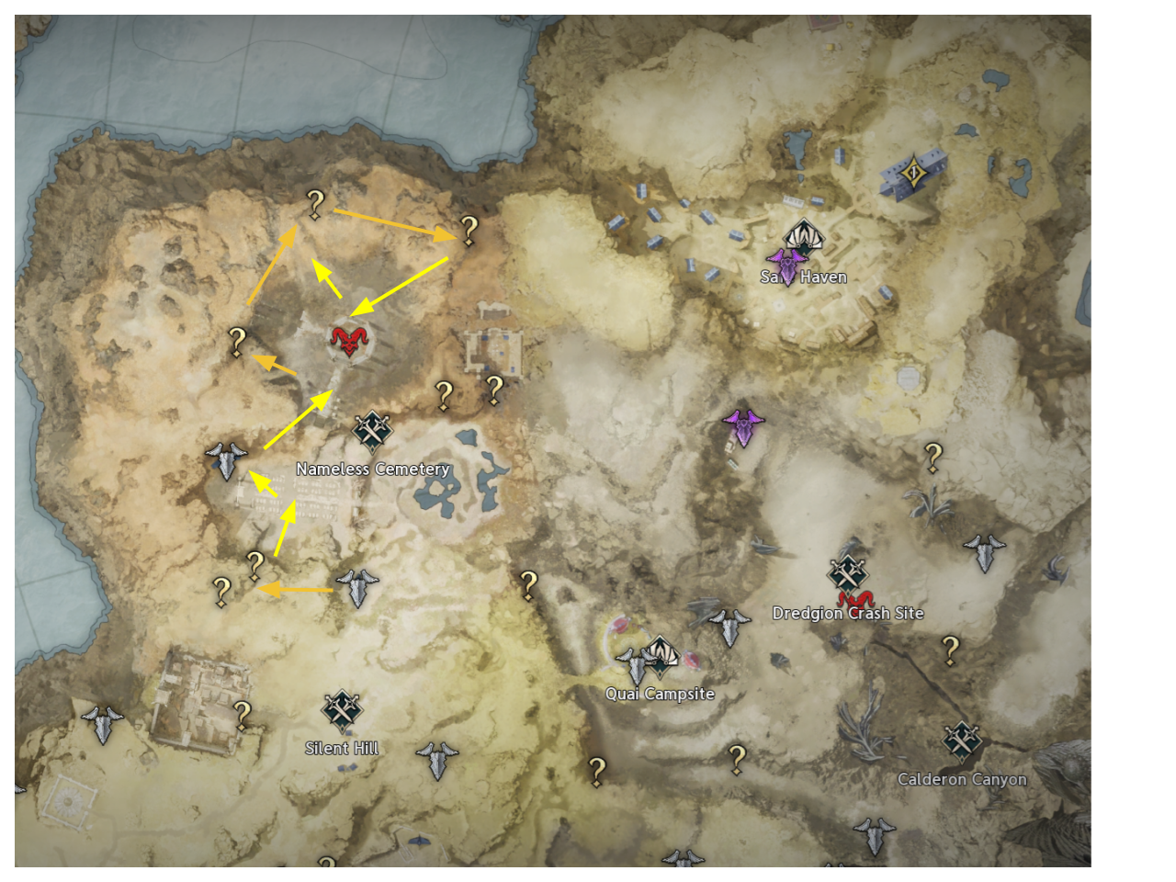
You get your first lvl8 skills here!
- MSQ
- Seal DG

Phase 3: Levels 17–21

Part 1
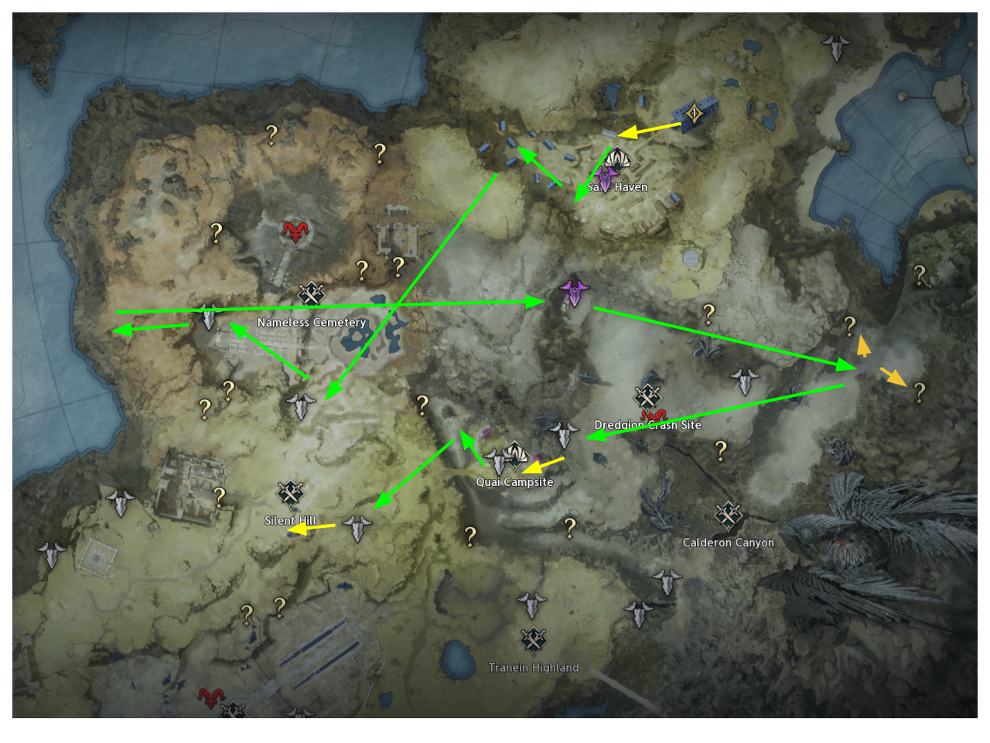
- Safe Haven: Take all the Green Quest’s and follow the pathing.

Part 2
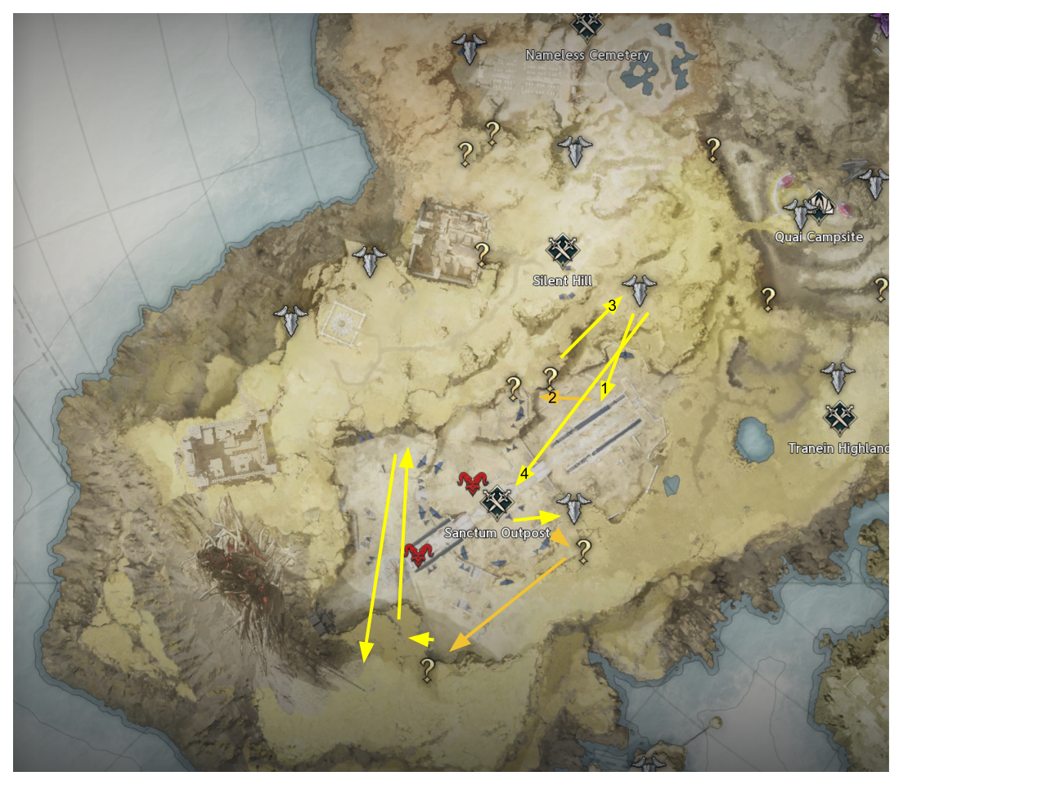
- Silent Hill: Focus on MSQ and do the 4 Seal dgs on the way!

Part 3
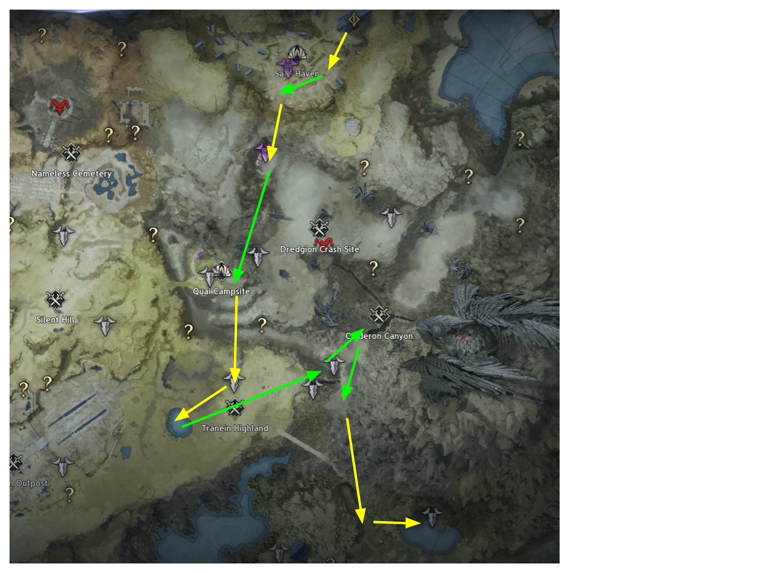
- Safe Haven Pickup: End all the quests equip the new Accessories and make them all +5!
- Recall: Teleport back to turn in all remaining pending quests.
  - Gear Check: Equip all newly acquired Accessories (upgrade to +5) and equip the smite Title.

Phase 4: Levels 22–32

Part 1
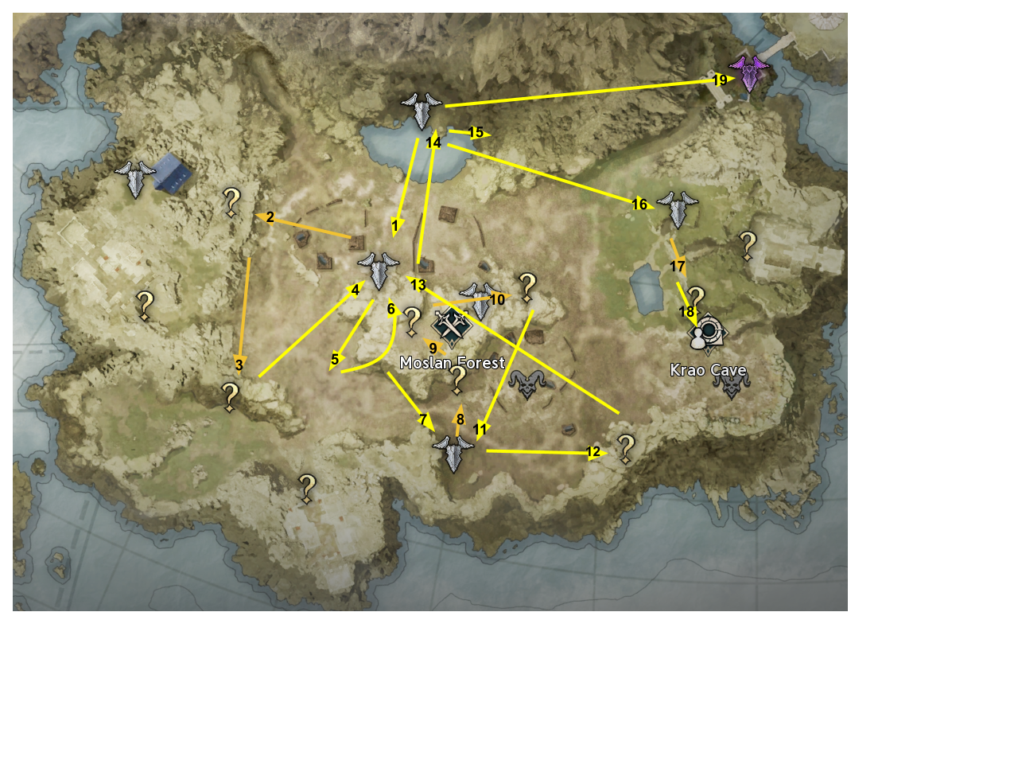
- Zone Entry: All we doing is MSQ and Seal dgs on the way!
After arrow 15 you get Ascension quest to get Stigmas!

Part 2
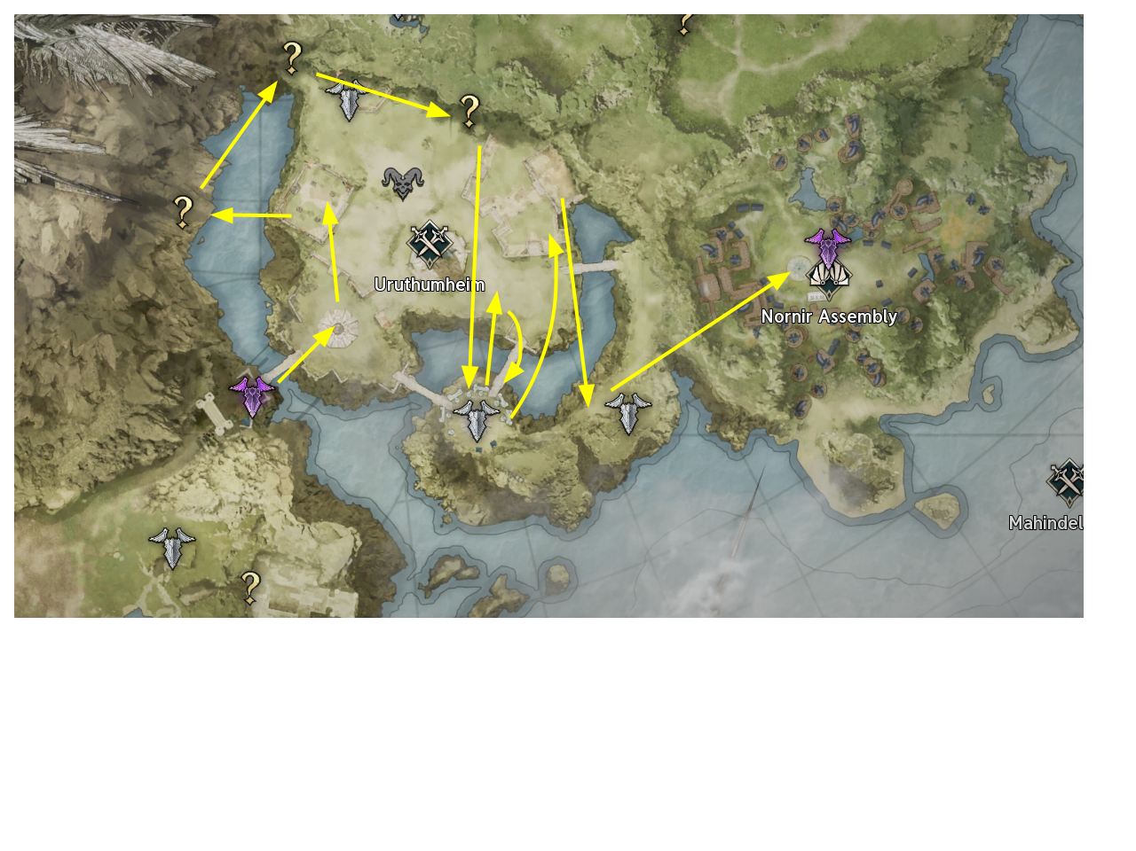
- Follow the MSQ and do the last 3 Seal dgs (You won’t do anymore until 45)

Part 3
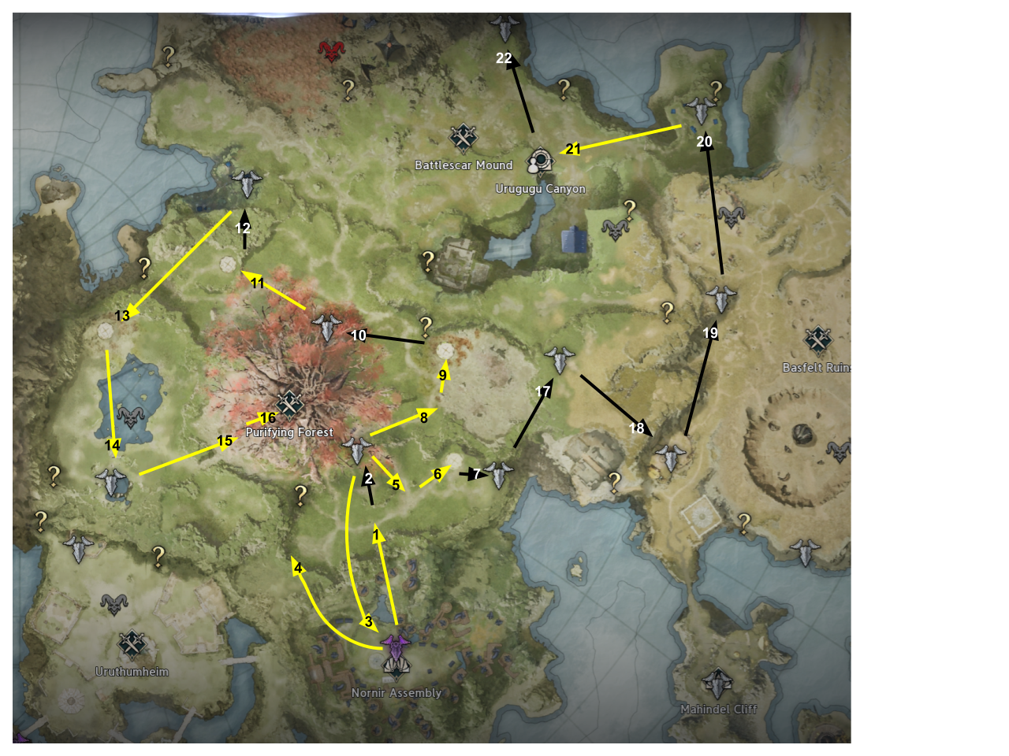
- Follow the MSQ and Take the Kisks it will save a lot of time for later stages!

Part 4: Level 32 First Rune Unlock Chain
After getting the Wings from Urugugu
- Rune Chain Start: Teleport to Nornir Assembly → Head to the Left side of Nornir Assembly → Accept and complete the side quest (Hugo Mercs pt.2 quest chain).
- Rune 1 Acquisition: Teleport to Abandoned Site → Accept and complete the local side quest to receive Rune 1.
- Equip & Upgrade: Open Inventory → Socket Rune 1 → Upgrade Rune 1 to +1.

Phase 5: Levels 33–45 (2nd Rune)

- Pure MSQ: From Level 33 onwards, focus 100% on Main Story Quests (MSQ). Only do green quests that coincide with the MSQ.
- 3rd Ascension (The One Who Dreams): After completing your 3rd Ascension take the green quest (Hugo Mercs pt.3) in Briskwind Shelter and get your 2nd Rune.
After that full MSQ! Enjoy!
Additional written notes during phase 5:
MSQ (Powder of Death): After killing 5 Insectoids and finding 2 lost bags take kisk (Amunta’s Hideout)
MSQ (Lake of Confrontation): After searching the Blades Supply Storage, leave through the door, fly into the fog EAST and take kisk (Idun’s Lake)
MSQ (An Ill Fate’s Resolution): Before diving into the lake fly over and take kisk (Steel Hammer Temp. Trading Post
MSQ (Daybreak Society Rescue Operation): After talking to Nemon to go distract Black Claw soldiers, take kisk (Kumrica’s Cellar) continued below~
In addition once you complete the instance atop the tree, when you must “talk to Nemon” take kisk SOUTH (Impetusium Lower Path)

